Schematic for 555-based timer circuit:

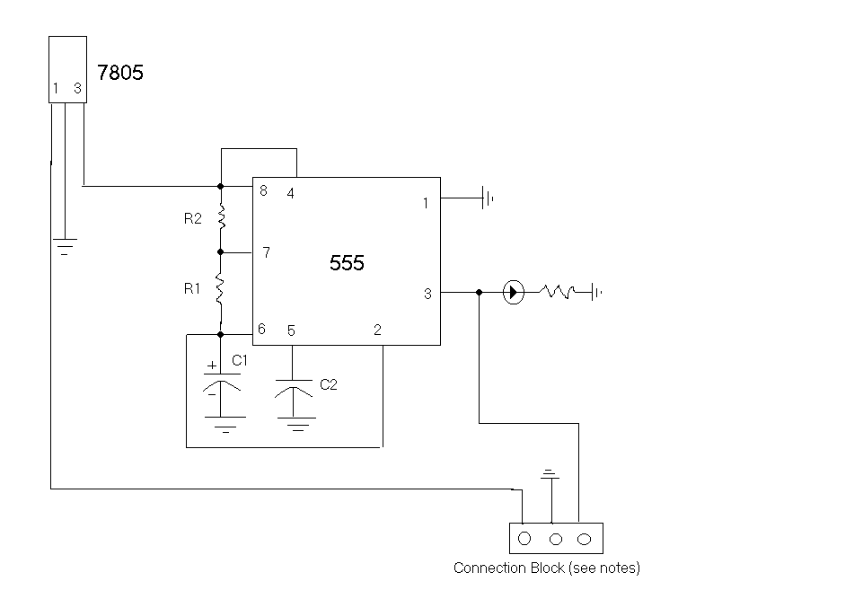
Capacitance and Resistance Values: See implementer’s notes.

555: 555 timer chip

7805: 5V 1A Voltage Regulator

All grounds connected

Diode: Is a RED LED. The resistor is a current limiting resistor. Set value as appropriate.

